**July 2015 Lightning Strikes More Than Once**

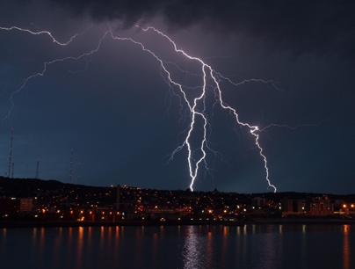

Did you know that July holds the record for the most structural damages and even casualties caused by lightning bolts per year, each year? Not only is July the hazardous peak time for the mysterious flashes of electricity, Central Florida is a peak target! Voltage can travel through soil to reach wiring and plumbing pipes that lead directly into your home. Make sure you have an emergency plumber, especially an out of this world plumber in the Orlando & Deltona areas.

Knowing the safety measures to protect yourself and the lives of your loved ones should be first and foremost on your readiness plan. But what should you do when the skies open up and wreak havoc on your residence or business? Even if the strike hits next to it, the voltage is strong enough to damage the structure, wiring and even buried pipelines.

Have a complete readiness plan in place so you don’t have to worry. The National Weather Service has some great in depth [Safety Tips](http://www.lightningsafety.noaa.gov/safety.shtml) to help protect your home. Some basic tips include:

1. Lightning Rods – Install to redirect the electrical charges away from your home or business
2. Don’t let your drain pipes act as conductors that can destroy your building’s foundation
3. Surge Protectors – Use to prevent wiring/electrical damage leading to fires
4. Avoid electrical appliances and any cords (DO NOT attempt to unplug anything)
5. Plumbing – Keep plumbing fixtures clear of standing water and free of metal dishes and appliances
6. Avoid using ANY plumbing during storms
7. Make sure metal dishes, gadgets and any cords are not left idle

Africa may be the lightning capital of the world, but Central Florida is the lightning capital of the United States! Make sure your pipes don’t make it easy on Mother Nature. Protect all plumbing fixtures from lightning. This includes:

* Water Heater
* Pool Equipment (including security fences & water surface alarms)
* Disposals
* Bathroom Fixtures

For more out of this world advice or to discuss drain cleaning and protection from the elements, [Contact Us](http://www.spacedraincleaning.com/contact-us/) for lightning fast service!